

**POLICY STATEMENT**

|  |  |
| --- | --- |
| Policy | Curriculum Policy |
| Date Written | Sept 2023 |
| Written by | M Shaw |
| Approved by |  |
| Updated | Summer 2023 |
| Next major review date | Summer 2024 |
| Location and disseminations | A copy of the policy can be found on the school website. |

**Curriculum Policy**

Our curriculum aims to be broad-based and inclusive, but with enough flexibility to allow each student to develop their individual strengths and interests.

Our curriculum does not undermine the fundamental British Values of democracy, the rule of the law, individual liberty and mutual respect and tolerance of those with different faiths and beliefs. Themes such as these are woven throughout our fields of study and, in particular, are specifically covered in our PSHE programmes of study and through the overarching educational philosophy of the school, the ’12 pillars’.

This policy document is aimed at all stakeholders and is designed to provide a description of the mechanism used to drive teaching and learning in the school. This policy should be considering alongside others, including safeguarding, behaviour, online safety, PSHE, staff code of conduct, H&S, EDI etc

**Our curriculum** seeks to

* Engage our students and develop **skills, knowledge** and discourse related to subject disciplines. Our students develop these according to their age, aptitude and interests.
* Ensure our students develop a thirst for knowledge through **enquiry,** a broad desire to learn more.
* Ensure our students can use the skills they have learned to **solve problems** with confidence, showing **resilience** and resourcefulness; even when tasks seem difficult at first.
* Ensure our students know where and how to source help when it’s needed, and generally be good **communicators**.
* Ensure our students can concentrate and work effectively, using **initiative and organisation** skills, whether in teams, pairs or individually.
* Ensure our students become increasingly **independent** and more able to reflect critically on their learning, identifying **strengths, areas for improvement** and how to make further progress in these area
* Ensure our students develop **Leadership** skills, the ability to lead and manage other people is a vital skill in the 21st century work place, it also takes a varied skill set – the ability to listen for example shouldn’t be underestimated. We present our students with the opportunities to develop these skills through our academic and extra curricular curriculum.
* Ensure our students both appreciate human achievement in all subject fields and enjoy their own personal **achievements** in these areas during their time at Buckswood.
* Ensure our students gain an understanding of the socio-cultural, geopolitical, environmental and economic aspects of the world, by drawing on the varying **perspectives** of our **international** community.
* Ensure our students can transfer and **apply skills and knowledge** between subject areas
* Ensure our students develop **Digital intelligence and awareness** – we want our students to be safe online and be responsible consumers of content like ‘social media’. We also want them to ‘critically consume’ information they come across in the digital world.

**Assessment and Reports**

|  |  |  |  |  |  |  |
| --- | --- | --- | --- | --- | --- | --- |
|  | Assessment point 1 | Assessment point 2 | Assessment point 3 | Assessment point 4 |  | Assessment point 5 |
| **1** |  |  |  |  |  |  |
| **2** |  |  |  |  |  |  |
| **3** |  |  |  |  |  |  |
| **4** |  |  |  |  |  |  |
| **5** |  |  | **Mocks Jan** |  |  |  |
| **L6** |  |  |  |  |  |  |
| **L6IB** |  |  |  |  |  |  |
| **U6** |  |  | **Mocks Jan** |  |  |  |
| **U6IB** |  |  | **Mocks Jan** |  |  |  |

Our Assessment structure is simplified below. Student reports are written by teachers following each Assessment point. Grades and reports are all entered on our SIMs system.

**Yellow** = Summative and Formative Assessment

**Blue** = Summative Assessment

**Green** = Public Exams

From academic year 2021, the school is moving away from it’s system of assessing each year group 6 times per year, to the model above. Things to note…

- Summative and formative means that students will be assessed on work they have done throughout the period of Assessment (Assessment 1 is Sept to Oct half term), this may include a test too. For example, in Geography Assessment 1 for Form 1, they may be marked on a presentation they have been given plus a test.

- An example of a departmental policy to assessment, is highlighted below and is also covered in departmental handbooks, managed by our **Heads of Department (HoDs)**

- A report will be written following each assessment point.

- Heads of Department and Heads of Key stage also perform a **Post Assessment Analysis.** Here we analyse trends and patterns, seeking to put in place strategies designed facilitate academic progress.

- Where there is a ‘white block’ no assessment will be sat, no reports or data will be produced. Feedback on progress and attitude can still be found in our weekly effort track reporting and communication with teachers/**Heads of Key Stage (3, 4 and 5)**

**Reasons for the change…**

* We believe it is not appropriate to simply assess a student’s ability based on a test they have sat, particularly in KS3
* We believe that in KS3, and at the start of our KS4 and 5 course, skill development is extremely important. In Science this might involve a focus on practical skills, in English it might be communication skills, and so on. Students should be assessed on these skills, not just summative assessment. 2023 will see the introduction of the KS3 ‘Buckswood Certificate’ designed as a multi disciplinary, concept based approach to learning.
* Reduces exam/assessment pressure
* Increases the time spent developing subject knowledge

Here is an example of the Maths Department policy to Assessment. Departmental policies can be found in the **Departmental Handbooks**.

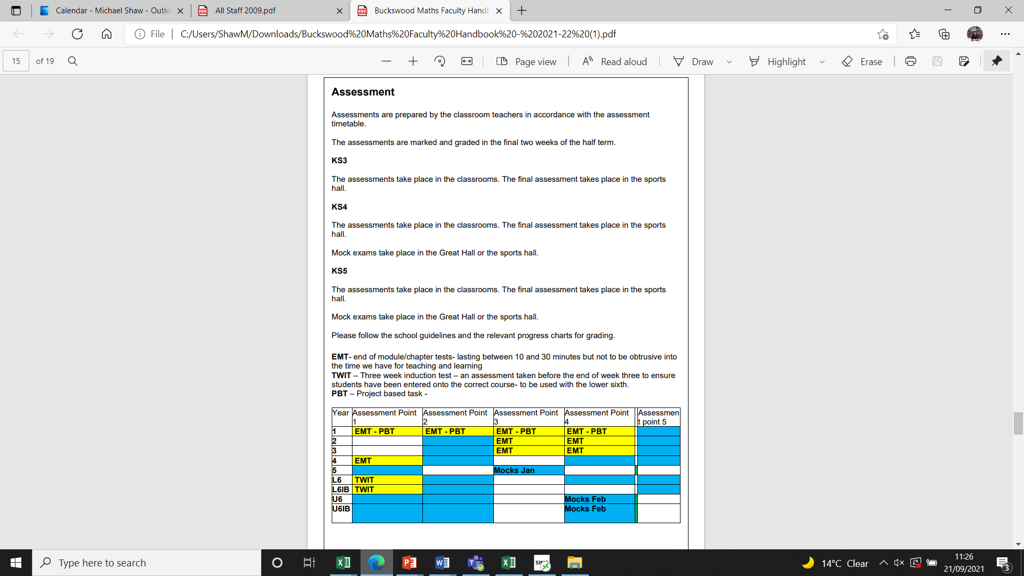

**Grading**

|  |  |
| --- | --- |
| **Form** | **Grading** |
| 1-3 | 7-1 |
| 4-5 | 9-1- U |
| A level (L6 and U6) | A*-U |
| IB (L6 and U6) | 1-7 |
| UFC | A*-U |

Assessment grades are issued to students and parents with the following information from Sept 2023..

*‘The grade that your child has received for this assessment reflects their* ***current working level*** *in this subject. This grade may go up or down depending on the progress your child makes over the remainder of the year/academic programme. Their assessment scores will be RAG (red, amber and green) to reflect if they are on track to meet their Agreed Targets or not (these are set at the start of the year)’*

An example of this is below (available for all stakeholders to see). Students are also graded on their effort, 1-4 (1 is Excellent).

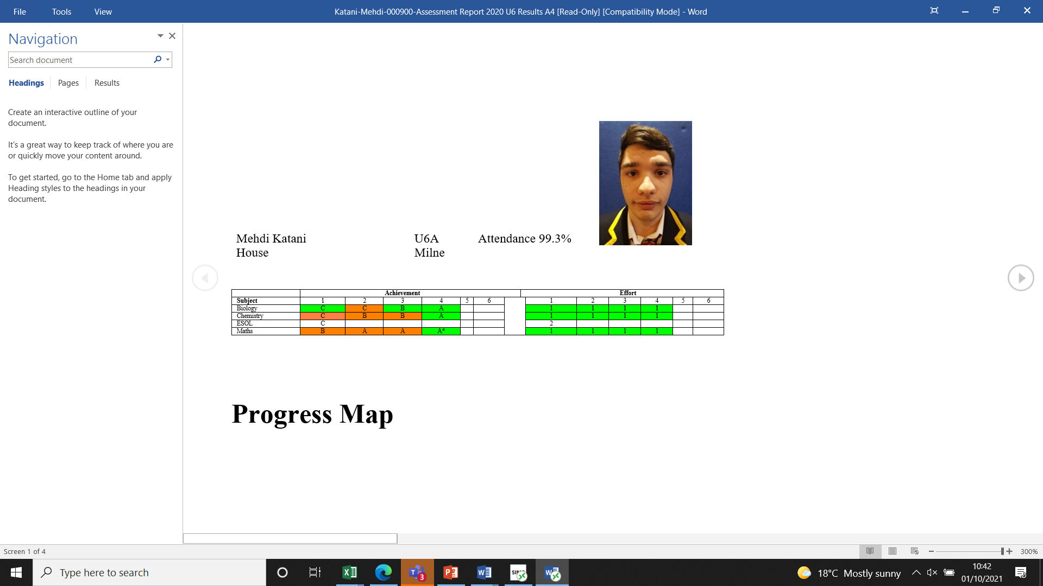

**Grades as they appear in SIMS**

KS3 students are graded using the data points below, these are used to assess if they are on track to meet their targets at each assessment point. A Form 1 student with a grade 6 as a target, should be at 2c after data collection point 1 (assessment 1).

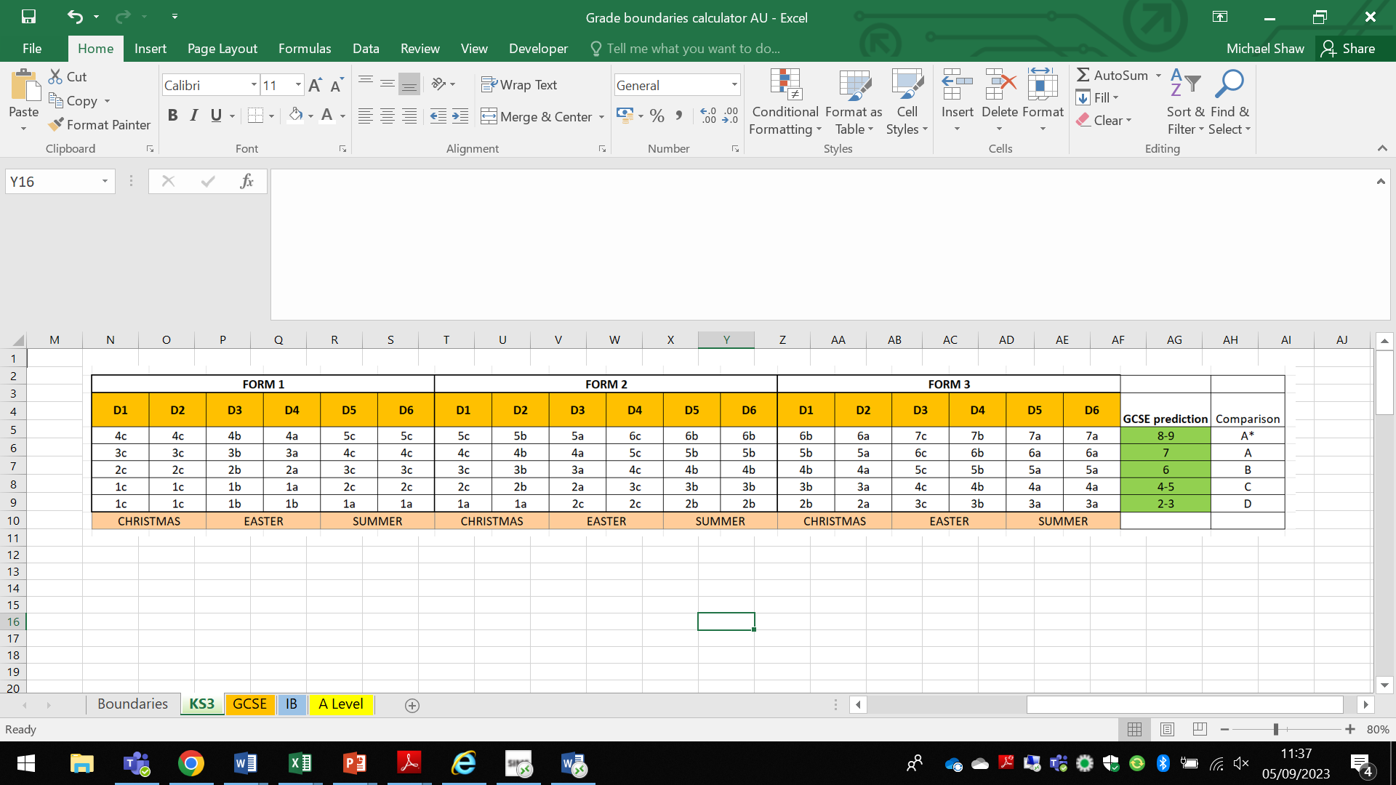

KS4 students are graded using the data points below, these are used to assess if they are on track to meet their targets at each assessment point.

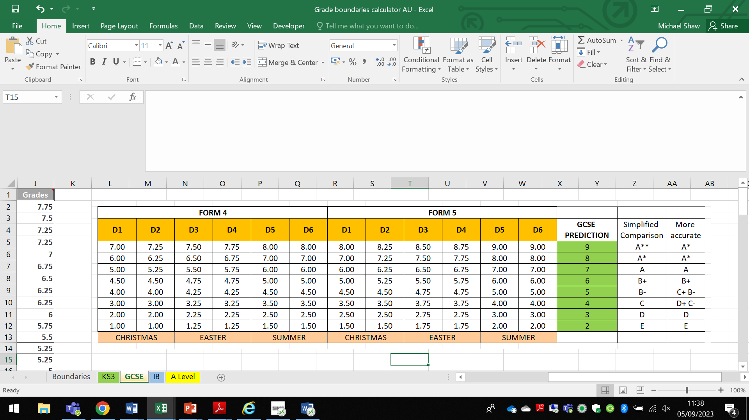

*KS5 A level* students are graded using the data points below, these are used to assess if they are on track to meet their targets at each assessment point.

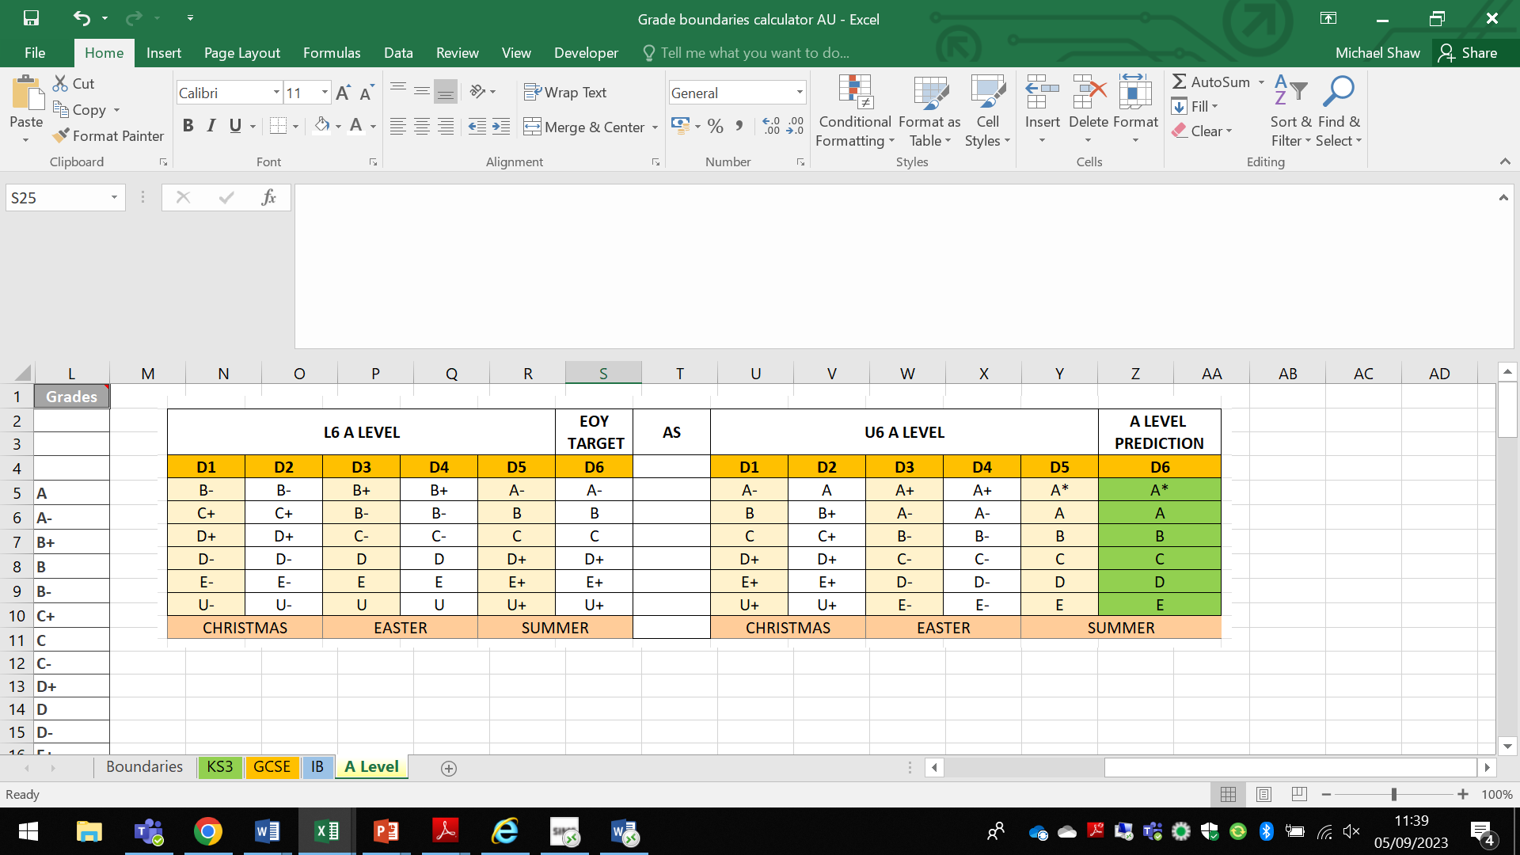

KS5 IB students are graded using the data points below, these are used to assess if they are on track to meet their targets at each assessment point.

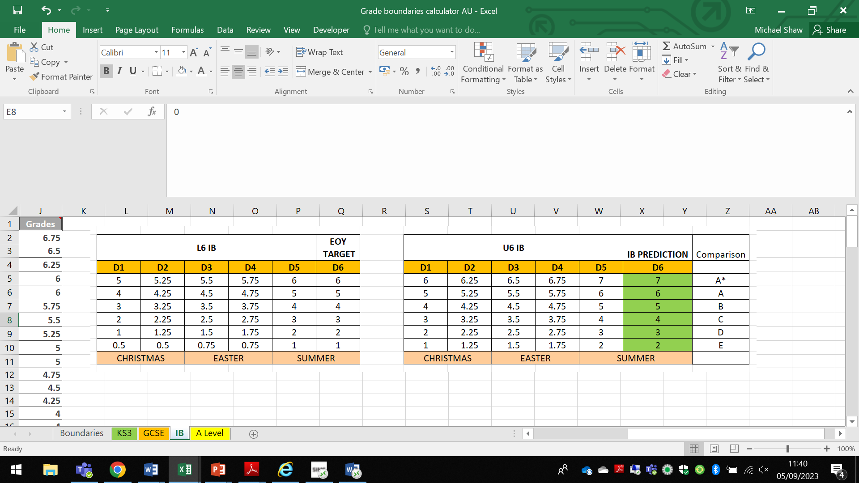

**The setting of tests**

Summative tests for Key stage 4 and 5 students are based on past paper examination material and marked using appropriate mark schemes. Tests are cumulative in nature, which means a student taking an end of year test will be expected to answer questions set against knowledge they have acquired across the whole year. Teachers understand that in Assessment 1 students have covered a small amount content and this is reflected in the standardisation of marks (an appropriate spread of marks factoring in the difficulty of the paper).

When students are awarded a grade, departments use their own grade descriptors to ensure the marks that are awarded are appropriate to the skills that are being demonstrated. This is more easily applicable in KS4 and 5 where we have published grade descriptors from exam boards.

**Baseline testing –** Cognitive ability tests (Alis) take place at the start of each academic year (Sept/Oct) to better understand the needs of our learners. Departments may also give a subject specific baseline test to understand their strengths and areas for development. Baseline testing is used to inform target setting.

**Targets** –Following baseline testing and Assessment 1 – the **ALIS target** and the **Agreed target** (following consultation between student and teacher) is entered into the class profiles on SIMS. **Agreed Targets** are available for all stakeholders to view, from Assessment 1**.** Teachers will comment on the performance of the student against their **Agreed Target** during periods of **feedback** (such as report writing following periods of assessment)

As above, student assessment scores will be RAGged (red, amber and green) to reflect if they are on track to meet their end of year target throughout the year. An example of this is below (available for all stakeholders to see). Students are also graded on their effort, 1-4 (1 is Excellent)



**Effort Tracker**

Each week, students will receive an effort grade (1-4, 1= excellent) from each of their teachers. We then create an average from all of their subjects, which then gets added to our Sims systems. We believe this is an effective way for attitude to learning (effort) to be monitored and challenged.

**Class profiles**

Class profiles, with appropriate contextual information allow teachers to effectively cater for all their students, there are found on SIMS. In any given year these include: Baseline test results and targets (as above), EAL level, Gender, Academy (sport) status, SEN status, any additional information that may assist teachers with their planning. It is vital this information is used to plan for the needs of all students.

**Cover policy –** when setting cover for absence, it is important teachers are prescriptive when detailing work to be completed on the online absence form. Work is sent to the cover teacher via email, it should also be placed in the room of the teaching requiring cover, where possible. Cover is allocated via Sims and also Outlook calendar notifications.Work for Sixth Form students is to be posted on Teams for them to complete in the library/TJs, where they are registered.

**Post Assessment Analysis –** Following an Assessment point, we ask our teachers, HoDs and Heads of Key Stage to produce a Post Assessment Analysis (See Assessment work Flow and PAA document in the Useful Documents section of Teams). The purpose of this is to highlight an areas of concern so that appropriate interventions can be put in place to facilitate progress.

**Lesson Expectations –** At Buckswood, we do not believe in a one size fits all approach to teaching. Our pedagogical approach varies from subject to subject, and from class to class, the nature of our school means that two lessons can never be the same.

There are however some fundamental requirements (linked to the Teacher standards) that should be in evidence and underpin a good lesson…

Clear objectives shared with students

Warm and welcoming approach from teacher

Reference to prior learning

Structure

Participation and engagement from student

Feedback given

Student centred learning

Use of IT

Differentiation: stretch & challenge + scaffolding for lower ability/SEN

EAL - vocab lists/keyword definitions

**The Use of AI –** Generative AI technologies have the potential to be transformative across the economy, and at Buckswood we recognise both their potential in improving the educational experience that we can provide, as well as the need to provide our students with the skills to work with and live with these technologies beyond their time at Buckswood. More details can be found in our use of AI policy (Useful documents)

**Dept Handbooks –** Each department has their own handbook, which includes department specific details on a range of topics, from schemes of work to assessment and feedback policy. These are stored on the school’s Microsoft Teams platform.

**Prep (Homework) -** Guidance on expected prep quantities below. Prep timetables are published on the school website.

|  |  |
| --- | --- |
| Year | Prep per week per subject |
| 1 | 1 |
| 2 | 1 |
| 3 | 1 |
| 4 | 2 |
| 5 | 2 |
| L6 | 2/3 |
| L6IB | 2/3 |
| U6 | 2/3 |
| U6IB | 2 |

**Prep**

Prep timetables are stored in Teams and online [Access Time and Prep - Buckswood School](https://www.buckswood.co.uk/academic/access-time/) . Sixth Form Prep is allocated at the discretion of the teacher (2/3 times per week), there is no set timetable. Flexibility is needed with the setting of Prep for the Sixth Form, as there are various other commitments, such as coursework/IA’s, exam components, that need to be considered. Teachers are expected to be aware of the demands placed on students, from other departments, at different times of the year (particularly true for IB).

**Feedback policy**

At Buckswood we strongly believe in ensuring our students receive appropriate feedback that they are able to use to improve their work and make progress. Feedback should come in many forms, we strongly encourage dialogue between teachers and students about their work and how it can be improved. Students should be empowered to ‘own’ the feedback provided.

Details of appropriate feedback can be found in the Useful Documents section of the Teachers Teams. Look for the Powerpoint entitled ‘Feedback policy – ideas for the classroom’. The level of feedback is monitored by HoDs, fortnightly by Heads of Key Stage and through learning walks and external academic consultants.

Here is an example of the Maths Department policy to feedback. Departmental policies can be found in the **Departmental Handbooks**.

**Maths Policy**

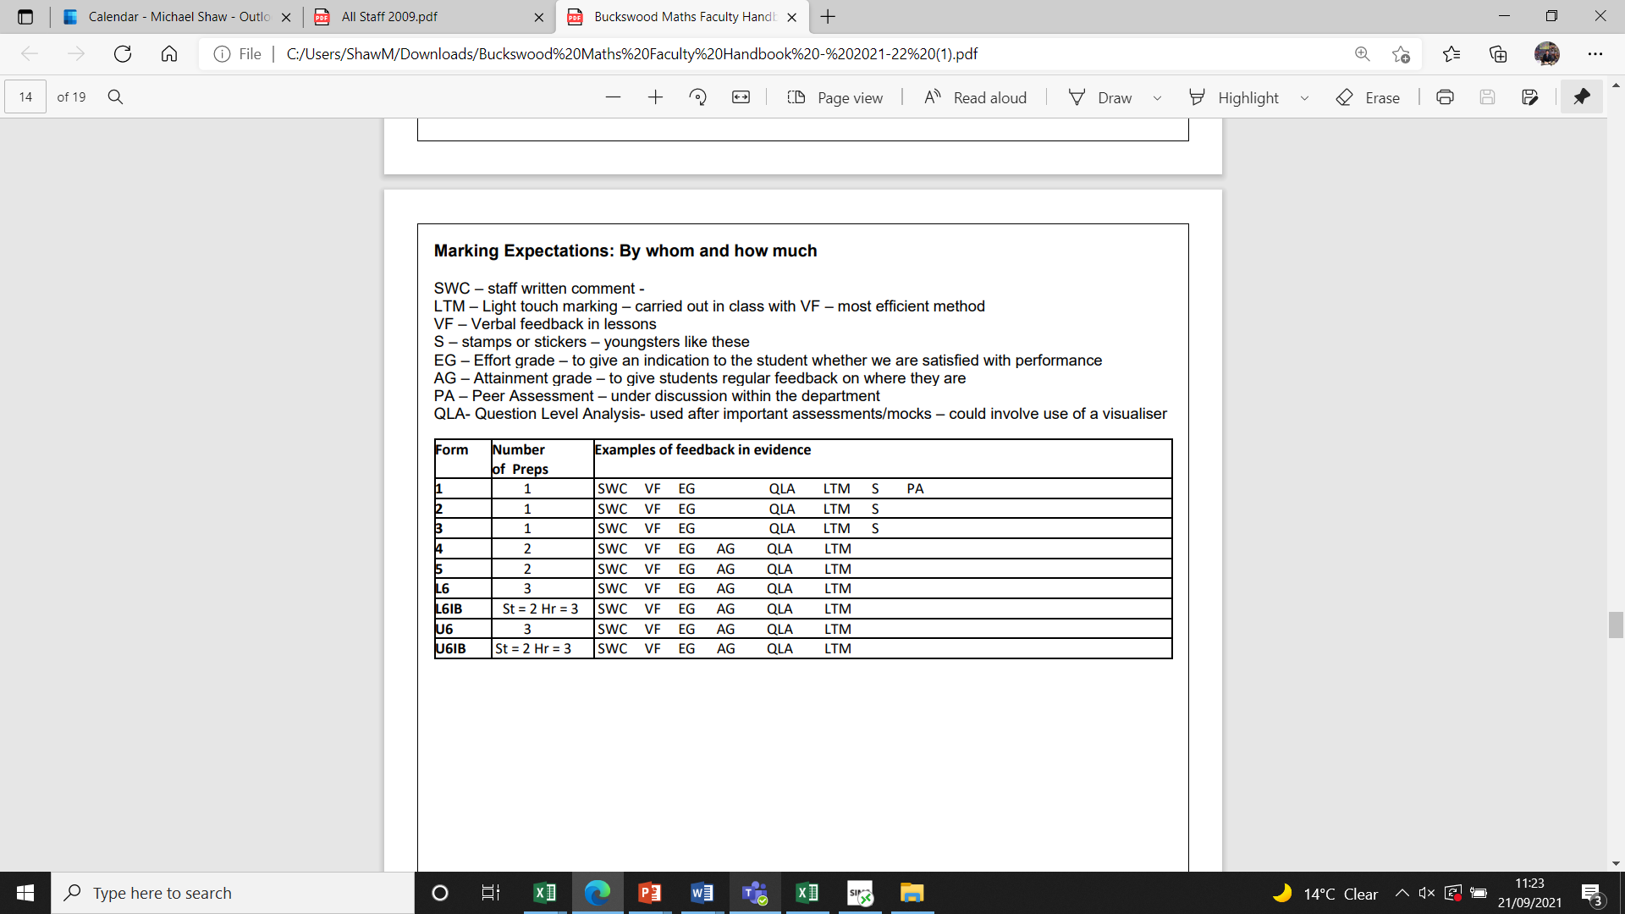

**Behaviour and Detentions**

A summary of our school rules can be found in the following link [Summary-of-the-rules-2021.pdf (buckswood.co.uk)](https://www.buckswood.co.uk/wp-content/uploads/2021/07/Summary-of-the-rules-2021.pdf) . This can also be found in the Useful Documents section of the Teachers Team. Detentions will take place on Mon, Tues and Thurs during Lunch and be led by Head of Key Stage/SMT. See **Detention Policy** in Useful Documents section of the Teachers Team.

**PSHE/RSE**

PSHE is taught as part of the timetabled KS3 curriculum. PSHE is delivered to KS4 and 5 during weekly 55 minute Form Tutor sessions. It is important to understand that PSHE related topics and attitudes permeate all we do as a school, it is not something that is simply taught in a specific slot.

PSHE requirements are evolving, we have to take account of our setting and students when planning PSHE. As such, to become more adaptable, we are moving to a termly KS4 and 5 focusing on pertinent issues. The academic and safeguarding team aims to provide you with lesson plans and resources for these activities.

Please see PSHE/RSE policy online. Please also see our Online Safety Policy

**Careers Education**

* Staff greatly support the students, often on a 1 to 1 basis, in respect to university applications and university choice. The Head of Year 13 meets with each member of the Sixth Form, more than once, to discuss university pathways, often on a 1 to 1 basis or as part of information sessions.
* The school organises university advice, personal statement and CV writing workshops, run by the ‘Life Skills Company’.
* Every term, all Key Stages receive careers and post-secondary information through our PSHE programme. A key part of this strategy is to invite guest speakers in to inform our students of the different post-secondary options available to them; this may also include hosting careers events at Buckswood and taking students offsite to careers events local to the school.
* The school hosts its own Buckswood University Fair every September, with a range of national and international undergraduate providers, working with the students to discuss options, accommodation, Visas and entry requirements. This is then followed up by school-supported / led visits to attend university open days.
* Each year, Buckswood takes students to local universities, such as Kent, Sussex and Surrey. This private tour allows our students to get a deeper insight into UK university life and, get their specific questions answered.
* Each year students also, mainly in Key stages 4 and 5, attend job, college and apprenticeship fairs at a local and regional scale.
* We run ‘student only’ and ‘student and parent’ information sessions regarding Buckswood GCSE and Sixth Form options, university and career choices are also discussed, in addition to this provision.

**Form Period and the role of the Form Tutor**

Being a Form Tutor is a vital role in the school, our Form Tutors are responsible for supporting their tutees academically and pastorally on a day to day basis. It is so important to start the day efficiently and with a focus. Some guidance for tutors and topics to cover are outlined below, this is subject to change ….

**Monday -**Reflect on the week and weekend that has passed – what were your positive/negative experiences and why. Students can reflect as individuals or as a group. Set goals for the forthcoming week. Prep diary checking should also be actioned by Tutors.

**Tuesday  -**Form tutors should lead a discussion about current affairs. A BBC news update can be helpful here.

**Wednesday  -**Mid-week mindfulness – this can be linked to PSHE, Current Affairs.

**Thursday**  - Log onto SIMS and check out how well I am doing.

**Friday –**12 Pillars – students to populate their Records of Success

**ICT for supporting student progress**

At Buckswood, our students have access to a suite of software resources, designed to assist them with their day to day organisation and understand their progress in all areas of their schooling. These resources allow students to access all written and numerical data about their time at school, also to converse and collaborate with teachers and colleagues on a day to day basis.

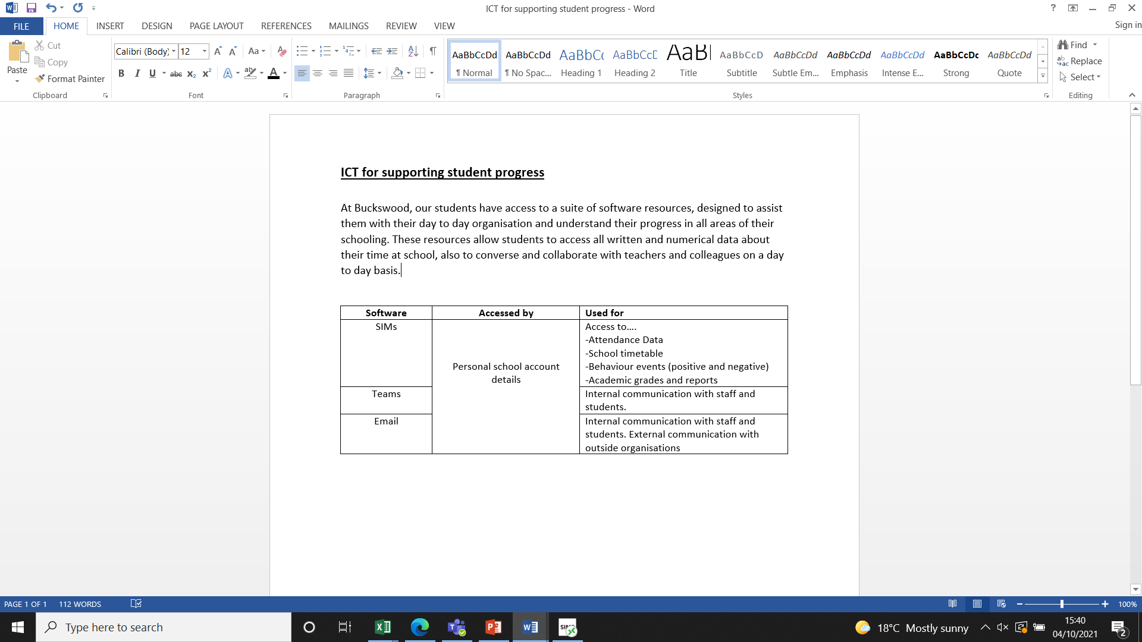

**Appraisal**

At Buckswood this is called the **Professional Performance Review (PPR)** and should be carried out by line managers as per the Communication Chart (Useful Documents – Teachers Team). A timetable for when these are to take place will be shared by the Academic Principal at the start of each academic year. PPR documents, to be completed, can be found in Useful Documents – Teachers Team. PPR’s are designed to support teachers in improving their practice and identify training needs. PPR is also used to identify how teachers can support the wider school ethos and community.

**Communication and reports**

Utmost professionalism is expected at all times in regards to internal and external communication. When writing reports, it is the responsibility of the teacher and Head of Department to check for grammatical errors, and ensure that the right tone is used. A standard formula for report writing is to highlight what has gone well during the period of assessment, and what can be improved. When writing emails to parents, please use Dear Mr and Mrs…

As a general rule of thumb, all **internal informal** communication should be conducted via Teams. **Formal internal** and **external communication** should be done via email.

**SEN**

All subject teachers are responsible for the learning of students with SEN, however we recognise that some students will require extra help and support in order to achieve their potential. Our service provides both group and individual lessons to support these students where possible and appropriate. Our SENCO liaises closely with form, subject teachers and SMT to ensure that our SEND students are working well and positively towards achieving their academic and personal goals. Where the LA has concluded a child should be placed at Buckswood under an EHC plan or a LAC, the day-to-day responsibility for that child’s provision rests with the Learning Support Coordinator (LSC). The LSC will be the named liaison with the relevant authority.

Any child with an EHC plan will be reviewed annually in accordance with LA practice. During the year, any revisions will be under the direction of the LSC. Progress and support will be recorded at all stages.

All subject teachers are responsible for ensuring their lessons are sufficiently differentiated to allow all students to make good, sustained progress. However, we recognize that some students who have significantly higher abilities than their classmates may need extra support/ challenge in order to ensure they reach their potential. For this reason, our SENCO liaises with subject teachers to ensure all our G&T students reach their potential

**Lesson planning**

There is no requirement to have a written plan for each lesson (although these are very useful for helping colleagues to organise structured lessons). It is important that in every lesson, students are given the opportunity to make progress, and that the teacher is in a position to facilitate and to evaluate that progress.

**Lesson observations**

Lesson observations, in the main, are undertaken by Heads of Department, SENCO and the Academic Principal. New teachers will always be observed at least once in the first half of term. Teachers are observed at least once annually by their Head of Department and as part of the PPR process. The Academic Principal will observe HoDs as part of the PPR process. Our SENCO will also observe lessons to ensure strategies to support SEN students are being used and to monitor individual and small group student progress. Learning walks are undertaken by the SLT at least once every half term, and have a specific teaching and learning focus, this could be behaviour, SEN, EAL, marking etc. The school always seeks to share best practice from lesson observations and these are designed to ensure, collectively, we are working towards securing the best possible outcomes for our students. Where teaching does not meet the required standards, observations will be used as part of a capability process. The school is positioned to recruit and support ECT’s.

**Inset and Training**

Colleagues are expected to explore opportunities for their own professional development, with requests to attend courses being submitted to the Academic Principal via the **Training (CPD) request form**, located in Useful Documents – Teachers Team. There should be a clear rationale for attending training and it is an expectation that outcomes of training are shared as appropriate. Weekly training session will be held by the Academic Principal, these will take place on Monday and recorded for those that cannot attend.

**Access Time**

Takes place between 1700-1740 and is an opportunity for students to receive additional support. Students should be encouraged to attend, particularly if there are concerns about progress. An example is found here…



**The Curriculum**

*Linguistic skills across the curriculum*

Because we want all of our students to become good communicators, literacy and associated linguistic skills are of paramount importance. Therefore, in all subject areas, students should be taught to express themselves coherently and articulately in both spoken and written standard English, with attention to appropriate register and to read and listen with understanding to both written and spoken forms of English across the spectrum of genres. Students are taught morphology, grammar and syntax, along with spelling and punctuation. They are taught to organise their written and spoken texts precisely and coherently, following a logical order and by using discourse markers to signpost progression or movement in the text. Students are taught reading skills, such as skimming and scanning, to extract information from texts or to follow a process or argument, as well as strategies for reading for understanding and enjoyment in more intensive reading tasks. Students are taught how to summarise, critically evaluate or rewrite texts in different genres, in order to adapt these for different purposes.

*ESOL at Buckswood*

The department aims to develop the English language ability of our learners, recognising and addressing their different needs. · With particular reference to Intensive English classes, there will be an early focus on spoken English skills so that learners can gain the confidence to play a full part in the school community. · The department will also act in liaison with other departments in order to support students’ access to the main school curriculum. The consideration of the needs of speakers of English as a Second Language is a requirement for all teachers at Buckswood School, and is expected to be evidenced in observed teaching

*Mathematical skills across the curriculum*

All subject teachers will, as and when appropriate, develop students’ numeracy, during the course of their lessons. Students are helped to make calculations, to understand and appreciate patterns in number and space and to develop a capacity to think logically. This may be done via asking students to present information via graphs, tables, etc, as well as asking students to calculate/estimate, using basic mental arithmetic or formulae. Lessons may be in practical sessions, exploration and discussion as well as written work. Where possible, links across the curriculum are made

*Scientific skills across the curriculum*

This area is concerned with increasing students’ knowledge and understanding of nature, materials and forces. Where possible, links across the curriculum are made

The teaching of Science subjects comprises a combination of hands-on, practical experimentation, enquiry-based study and guided study in the natural environment of the school campus, on field trips, museum trips, etc

The study of Science teaches processes of great, cross-curricular value such as: observation, hypothesis formation and carrying out experiments, recording results that prove or disprove a hypothesis.

*Technological skills across the curriculum*

All subject teachers will give students the chance to develop their ICT skills during the course of their lessons, by using ICT tools to support learning and by asking students to use ICT tools to present and demonstrate understanding of lesson content. Buckswood’s Microsoft Teams suite of packages is used by all students to hand in for numerous school based task and communications.. Students have access to revision software, to help them revise for their GCSE and Sixth Form examinations and there is an ICT suite, including film editing and sound recording sections to allow students to be creative with ICT tools.

ICT is taught throughout KS3. IGCSE computing is offered should students wish to pursue this in KS4 and at A level.

*Religious Education*

Religious Studies and Ethics are woven into the relevant sections of our PHSE/RSE curriculum and school assemblies, particularly sections concerned with social norms and cultural practices.

|  |  |  |
| --- | --- | --- |
| **Software** | **Accessed by** | **Used for** |
| SIMs | Personal school account details | Access to….  -Attendance Data  -School timetable  -Behaviour events (positive and negative)  -Academic grades and reports |
| Teams | Internal communication with staff and students. |
| Email | Internal communication with staff and students. External communication with outside organisations |

*Physical Education*

Students gain knowledge and understanding of the basic principles of fitness and health. Students have access to two hours of PE per week, although many students opt to do more, via participation in sports squads, sports clubs and enrichment programmes,. Sports covered range from: football, futsal, rugby, hockey, netball, tennis, swimming, volleyball, archery, golf and badminton. Students also do fitness training and cross country running. We have specialist academies for football, rugby, netball and golf. Furthermore, we aim to help students to evaluate and improve their performance. For academic year 2020-2021, following an extended period of Covid lockdown and concerns about the transmission of the illness in Music, the school is providing an extra X2 lessons of PE per week for KS3.

*Aesthetic and Creative Curriculum*

This area is concerned with the processes of making, composing and inventing. We believe that creative subjects, such as Music, Art and Drama have a highly positive effect on the development of the brain and thus, on learning and learners. For academic year 2021-2022, following an extended period of Covid lockdown and concerns about the transmission of the illness in performing arts (music and Drama), the school is providing an extra X2 lessons of PE per week for KS3, which will replace our performance arts provision. Students wishing to learn an instrument and partake in Drama can access these through P7 activity programme and by requesting one to one lessons (below) .Students are encouraged to perform in assemblies and concerts, to gain experience and enhance their skills. Students also take part in trips to theatre/musical productions and concerts, both locally as well as in London. As above, we can provide one to one tuition for most musical instruments and will always strive to find local tutors for more unusual instruments. Art is taught at KS3, Art & Design and Graphics are taught at KS4 Art & Design and Photography are taught at KS5 All these subjects are supported by: visits to exhibitions, field trips, talks by visiting artists, photographers and film-makers. The study of literature (in all the languages that we teach) also calls for personal, imaginative and often practical responses.

[Music and Drama lessons (google.com)](https://docs.google.com/forms/d/e/1FAIpQLSdsVifzHq86dOVhltfV8dSceSuQDItqbAZtPOJznAy6LYj6VA/viewform)

*Languages*

Languages Buckswood has been recognised across the world as a centre for internationalism. We have students from all continents on one campus, a truly global community, living together and learning from one another. Accordingly, we recognise that with some many students coming from diverse backgrounds and nationalities all teachers are, in practice, language teachers with responsibilities in facilitating communication. At Buckswood School we understand that:

• Language is a primary means of communicating and learning.

• The acquisition of language is a life-long process and is a central component of intellectual and personal growth.

• Proficiency earned in one language is transferable to other languages, and language proficiency aids the student in acquiring competencies in other curricular areas.

• Language is an expression of culture and must be valued as an integral part of a student’s identity.

• The development of the mother-tongue language is critical for maintaining one’s cultural identity.

• Language learning promotes internationalism and multicultural understanding.

• Language learning must be fostered in all aspects of the school community

Detail on languages offered can be found here [Language Lessons (google.com)](https://docs.google.com/forms/d/e/1FAIpQLSel4Ae7rKCCgvwOc-K5ubSswOADsan3p0AL1nPycYJeX1Zv5Q/viewform) We will also try to accommodate other language request through appropriate online tutoring as and when required

**Lesson 7 – 1600 – 1700 – Spiritual, Moral, Social, Cultural Development**

At Buckswood we offer after school clubs, weekend clubs, but also believe in the value of extending our students each day beyond the confines of the classroom. ‘Lesson 7’ is our extra curricular time during the school day (1550 – 1700) and for the senior school has replaced ‘Prep’ on the timetable. There will now be a greater emphasis on completion of Prep in the evening and, for Sixth Form, effective use of study periods during the day. Prep will remain for Key Stage 3 and their ‘Lesson 7’ slot will be on Wednesdays.

Staff have been selected to run ‘Lesson 7’ activities based on the skills they are able to offer our students. Students select one choice from a selection of activities at the start of each term, where they will remain for the duration. This ensures students work towards appropriate end of term outcomes and achievements, facilitated by the member of staff leading the activity (termly lists of activities will be posted online and in shared areas online).

There are members of staff who are not leading ‘Lesson 7’ activities. Mostly, but not in all cases, these are HoDs, Heads of Key Stage, teachers who teach across the Key Stages. During Lesson 7, these members of staff will be involved in Training sessions and Dept meetings as per their role. Dept meetings and Training must be recorded on Teams so that colleagues leading ‘Lesson 7’ activities have access. Under this system, all teachers should gain an extra marking period per week. Those leading ‘Lesson 7’ activities each evening will not be Form Tutors. Form Tutors of Key Stage 4 and 5 students will lead PSHE and Careers sessions on Weds during ‘Lesson 7’.

A timetable for ‘Lesson 7’…

|  |  |  |  |  |  |
| --- | --- | --- | --- | --- | --- |
| **Key stage** | **Mon** | **Tues** | **Weds** | **Thurs** | **Fri** |
| **3** | Activities | Prep | Activities | Prep | Assembly |
| **4** | Prep/Activities | Prep/ Activities | PSHE/Careers | Prep/Activities | Assembly |
| **5** | Prep/Activities | Prep/Activities | PSHE/Careers | Prep/Activities | Assembly |

|  |
| --- |
| Football Academy |
| Rugby Academy |
| Duke of Edinburgh |
| Netball |
| Fitness/General Sport |
| Art |
| Model United Nations |
| Music |
| Drama |
| Chinese |
| Cooking |
| Tennis |
| Independent Learning |
| Cricket |

**The Not so Boring Office** – runs a host of other extra-curricular activities and driving lessons. Work experience can also be sought and arranged through this office

[Not So Boring office Activities (google.com)](https://docs.google.com/forms/d/e/1FAIpQLScP2eNoi92_-96iVzMDb29Tj4bp_W7Bm0yO7tWo60PMuec4sw/viewform)

**Study periods**

These lessons are spent doing independent work in the Library under close teacher supervision. Students who are pursuing fewer subjects at GCSE, and those who are being taught outside the timetable to facilitate a particular option combination will have ‘library’ sessions on their timetable. Sixth Form students with study periods use the library (Lower Sixth) and TJs (Upper Sixth).

**Curriculum plan 2023-2024**

**Reg = 0845 – 0910**

**P1 - 0910-1005**

**P2 -1005 – 1100**

Break – 1100 – 1115

**P3 - 1115 – 1210**

**P4 - 1210 – 1305**

**1305-1325 = Lunch 1 – Detention – 1305 to 1345**

**1325 – 1345 = Lunch 2**

**1345 – 1400 – Lunch 3**

**P5 - 1400 – 1455**

**P6 - 1455 -1550**

**Break - 1550 – 1600**

**1600  - 1700 - P7 – Prep or Activities**

**Access – 1700 – 1740**

**Junior curriculum**

1 lesson = 55 minutes

|  |  |  |
| --- | --- | --- |
| **Form 1** | | |
| **Subject** | **Form** | **Lessons Required** |
| English | 1A/EN1 | 4 |
| Maths | 1A/MA1 | 4 |
| Science | 1A/SC1 | 3 |
| Geography | 1A/GG1 | 2 |
| History | 1A/HI1 | 2 |
| Computing | 1A/CO1 | 2 |
| PSHE | 1A/PS1 | 1 |
| Art | 1A/AR1 | 2 |
| French | 1A/FR1 | 2 |
| Spanish | 1A/SP1 | 2 |
| Chinese | 1A/CN1 | 2 |
| **Games** | **F2/3/GA1** | 4 |

**GCSE curriculum (over 2 years)**

|  |  |  |  |
| --- | --- | --- | --- |
| **Form 4 (2 year GCSE)** | | | |
| Option Bock | Subject |  | Lessons Required for form |
| **Core 1** | Games | 4/GA1 | 2 |
| **Core 2** | English | 4E/EN1 | 6 |
| English as second lang | 4ESO/Es1 | 6 |
| **Core 3** | Maths | 4M/MA1 | 5 |
| **Core 4** | Science | 4S/SC1 | 5 |
| A | Business | 4A/BE1 | 4 |
| Computer Science | 4A/CS1 | 4 |
| Graphics | 4A/GR1 | 4 |
| Geography | 4A/GG1 | 4 |
| PE | 4A/PE1 | 4 |
| B | Business | 4B/BE1 | 4 |
| French | 4B/FR1 | 4 |
| History | 4B/Hi1 | 4 |
| Geography | 4B/GG1 | 4 |
| C | Art | 4C/AR1 | 4 |
| Triple Sci | 4C/TS1 | 3 |
| Spanish | 4C/SP1 | 4 |
| Chinese | 4C/Cn1 | 4 |
| History | 4C/Hi1 | 4 |

**GCSE curriculum (over 1 year)**

|  |  |  |  |
| --- | --- | --- | --- |
| **1 year GCSE (Form 5X) Lower level group** | | | |
| Option Bock | Subject |  | Lessons Required for form |
| 1 | Games | 5/GA1 | 2 |
| 2 | English (timetabled with 2 yr) |  | 5 |
| 3 | Maths | 5X/MA | 5 |
| 4 | Science | 5X/SC | 6 |
| 5 | Business | 5X/BE1 | 6 |
| 6 | Extra ESOL | 5C6/Es2 | 2 |
| 7 | ECDL | 5X/CO1 | 2 |
| 8 | Indp Study |  | 2 |
|  |  |  |  |
|  |  |  |  |
| **1 year GCSE (Form 5Y) Higher level group** | | | |
| 1 | Games | 5/GA1 | 2 |
| 2 | English (timetabled with 2 yr) |  | 5 |
| 3 | Maths | 5X/MA1 | 5 |
| 4 | Science | 5X/SC | 6 |
| 5 | Geog | 5X/GG1 | 6 |
| 6 | Businesss | 5X/BE2 | 6 |

**A level Curriculum –** Maths and English GCSE retake support is also available, should students require it.

|  |  |  |
| --- | --- | --- |
| **A level** | | **Lessons** |
| A | Chemistry | 6 |
| Art |
| Geog |
| Economics |
| Business |
| Law |
| B | Physics |
| Psychology |
| Politics |
| Maths |
| Business |
| C | Biology |
| Photo |
| History |
| Maths |
| Spanish |
| PE |
| French |
| D | ESOL | 2 |
|
| E | Games | 2 |
| F | ESOL Extra | 4 |
| ECDL | 2 |
| G | Further Maths | 3 |

**IB curriculum**

|  |  |  |  |
| --- | --- | --- | --- |
| **L6 IB** | | | |
| **Option Block** | **Subject** | **Code** | **Lessons Required for form** |
| 1 | English A | L61/ZE1 | 5 |
| German A | L61/ZI1 | 5 |
| French A | L61/ZG1 | 5 |
| Spanish A | L61/ZS1 | 5 |
| Russian A | L61/RZ1 | 5 |
| 2 | English B | L62/ZF1 | 5 |
| French B | L62/ZH1 | 5 |
| 3 | Business Management | L63/BM1 | 5 |
| 4 | Physics | L64/PZ1 | 5 |
| Biology | L64/BZ1 | 5 |
| 5 | Maths Applications & Interpretation | L65/MZ1 | 3 |
| Maths Analyis and Approaches | L65/ZM1 | 5 |
| 6 | Visual Arts | L66/AZ1 | 5 |
| Chemistry | L66/CZ1 | 5 |
| Spanish ab initio | L66/SZ1 | 3 |
| Geography | L66/GZ1 | 5 |
| Core | TOK | TOK1 | 2 |

**University Foundation Course**

|  |  |  |  |
| --- | --- | --- | --- |
| **Business Foundation Course (UFC) - Upper Sixth** | | | |
| Option Bock |  | Lessons | Subject |
| 1 | UFC/BM1 | 14 | Business Management |
| 2 | UFC/MA1 | 4 | Maths |
| 3 | UFC/ES1 | 4 | ESOL |
| 4 | F6/GA1 | 2 | Games |
| 6 | UFC/Li1 | 5 | Study |

**Intensive English (subject to change based on demand)**

|  |  |  |
| --- | --- | --- |
| **Intensive English 1** | | |
| **Option Bock** | **Lessons** | **Subject** |
| 1 | 14 | ESOL |
| 2 | 14 | ESOL |
| 3 | 2 | Games |
|  |  |  |