Christmas Term uniform

If you require any items from the shop then please can you book a time to visit. Please email shop@buckswood.co.uk . Alternatively, you can email your request in to us with measurements and this can be boxed up and put aside for you. There is a good stock of ‘second hand’ uniform’ available, however cash needs to be paid for these items.

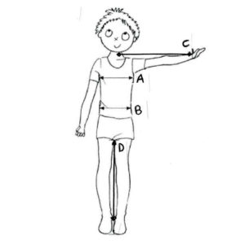
Required Information when ordering

Measurement A (Around the chest in cm's)
Measurement B (Around the waist in cm's)
Measurement C (Sleeve length, centre of neck to wrist in cm's)
Measurement D (Inside leg in cm's)

Item | New (£) | Second Hand (£)
Blazer * | 90 | 40
Padded Coat * | 70 | 35
V neck * | 35 | 18
Hat * | 9 | 5
Scarf * | 15 | 12
Rucksack | 20
Waistcoat (Male) * | 40 | 20
Long Gentlemans coat | 100 | 50
Bow tie * | 6 | 3
Trousers | 24
White shirt (twin pack) | 15
Girls Kilt * | 34 | 25
Girls Waistcoat * | 35 | 20
Black skirt (6th form) | 19 | 10
School Tie * | 7 | 5
Sports Kit
Sports top * | 35 | 20
Sports shorts * | 25 | 15
Sports socks * | 8
Track suit jacket * | 60 | 30
Track suit trousers * | 35 | 25
Boot bag | 7 | 4
Full sports kit (above) | 150 | 78

* compulsory items

