WHO TO TALK TO AT BUCKSWOOD SCHOOL
If you need advice, are having difficulties or want to talk to someone, there are a number of people available:
- Form Tutor
- Boarding House Staff
- Subject Teacher
- Head of Year :
- Forms 1 and 2 – Mrs Bramley
- Form 3 – Mr Foster
- Form 4 – Mr Rodriguez
- Form 5 – Ms Rodgers
- Lower 6 – Mr Bramley
- Upper 6 – Mr Shaw
- IB – Mrs Richards
- Safeguarding Team : Mr Commane or Anne Jeffery (in the Hub)
- Head of Boarding : Miss Jenny
- Nursing staff (at BHS)
- School Counsellor : Di Dunmall (at BHS)
- Independent Listener : Alison who can be contacted on 07376 557144
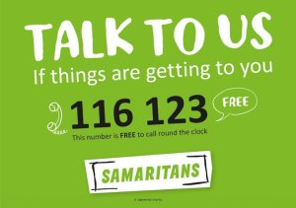
Other support is also available through:
