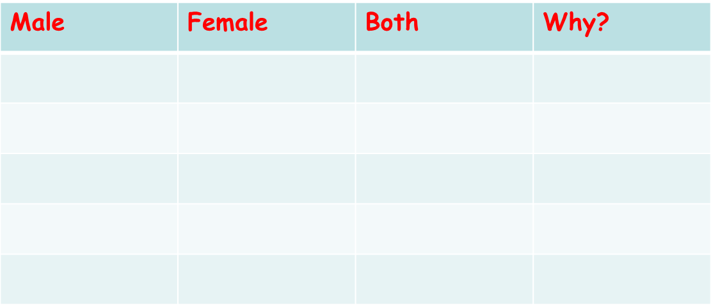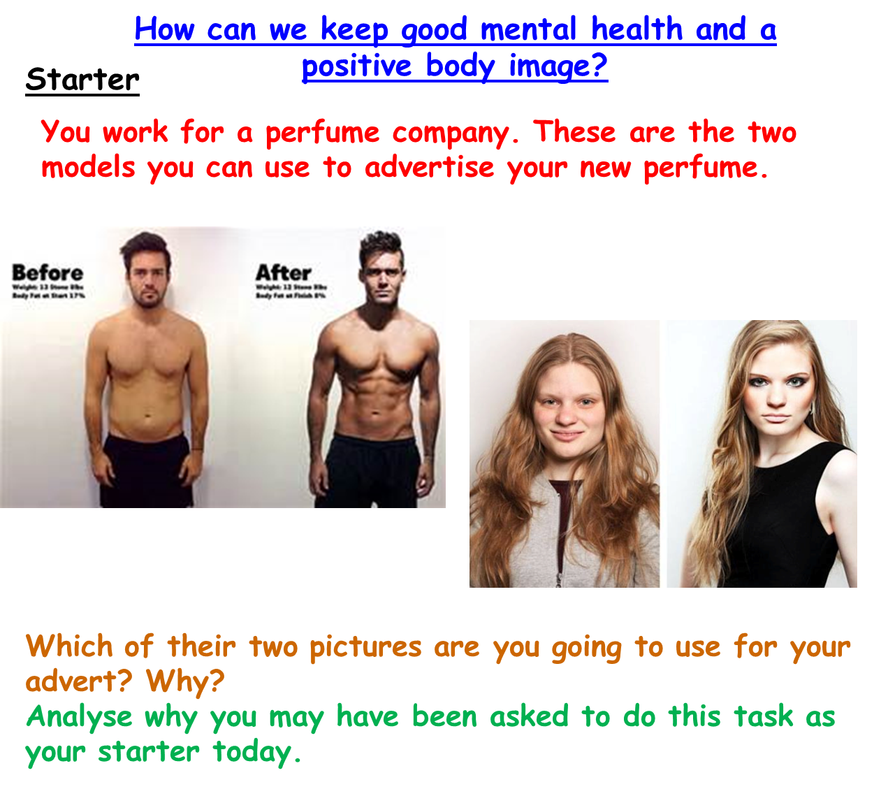

As you watch the clips, on your table complete the issues males, females and both are most worried about as well as why.