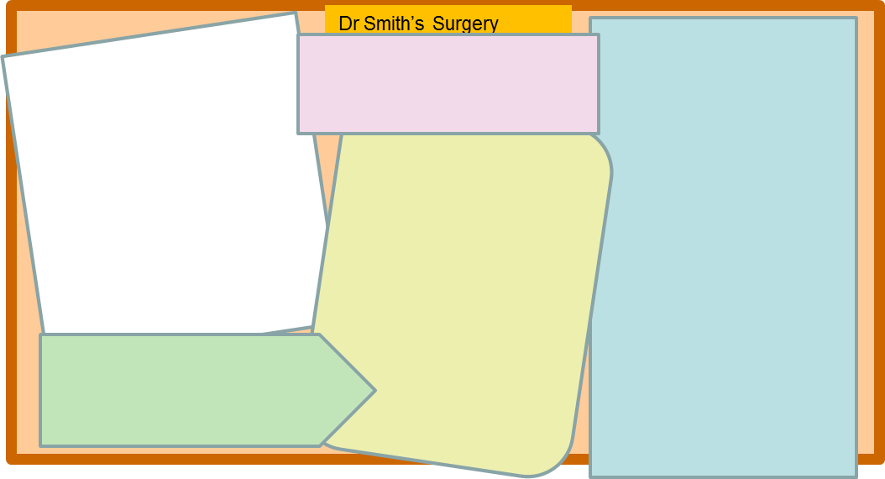

Describe three symptoms of each disorder and one way the disorder could be treated.

As above, but also describing how ways managing our physical and mental health could help to treat these disorders.

Explain which mental health symptoms might be found with each disorder and how mental health symptoms should be treated too (look back in your book) in order to help prevent eating disorders.