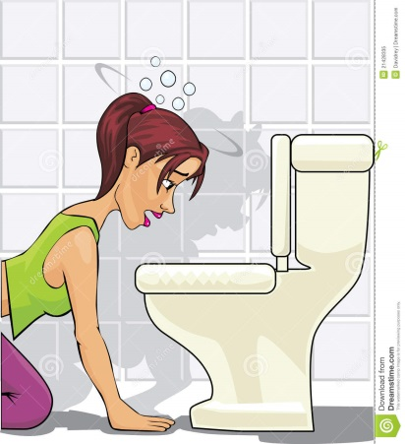

Bulimia Nervosa
People who have bulimia try to control their weight by severely restricting the amount of food they eat, then binge eating and purging the food from their body by making themselves vomit or using laxatives.
As with other eating disorders, bulimia nervosa can be associated with low self-esteem , alcohol misuse, depression and self-harm. It is as important to treat these causes as it is the symptoms.
People suffering from eating disorders tend to use their eating habits and behaviours to cope with emotional distress, and often have an abnormal or unrealistic fear of food, calories and being fat.
Signs of bulimia nervosa include an obsessive attitude towards food and eating, an overcritical attitude to their weight and shape, and frequent visits to the bathroom after eating, after which the person might appear flushed and have scarred knuckles (from forcing fingers down the throat to bring on vomiting).
As with all eating disorders, women are much more likely to develop bulimia than men. However, bulimia nervosa is becoming increasingly common in boys and men. There are an estimated 1.6 million Britons suffering from some form of eating disorder, and reports estimate that up to 25% may be male.
The first step towards getting better is to recognise the problem and to have a genuine desire to get well. There is strong evidence that self-help books can be effective for many people with bulimia nervosa, especially if they ask a friend or family member to work through it with them.
If this is not suitable or is unsuccessful, your GP can refer you for treatment to an eating disorder service, where you may be offered a structured programme of cognitive behavioural therapy (CBT).
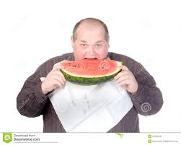

Obesity
It's a common problem, estimated to affect around one in every four adults and around one in every five children aged 10 to 11 in the UK.
Obesity can also affect your quality of life and lead to psychological problems, such as low self-esteem or depression. Obesity is generally caused by consuming more calories – particularly those in fatty and sugary foods – than you burn off through physical activity. The excess energy is then stored by the body as fat.
Obesity is an increasingly common problem, because many modern lifestyles often promote eating excessive amounts of cheap, high-calorie food and spending a lot of time sitting at desks, on sofas or in cars.
The best way to treat obesity is to eat a healthy, reduced-calorie diet and to exercise regularly. To do this you should try to eat a balanced, calorie-controlled diet as recommended by your GP or weight loss management health professional (such as a dietician) or join a local weight loss group.
Another good idea is to take up activities such as fast walking, jogging, swimming or tennis for 150-300 minutes a week and to eat slowly and avoid situations where you know you could be tempted to overeat.
You may also benefit from psychological support from a trained healthcare professional, to help change the way you think about food and eating.

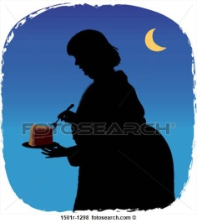

Night Time Eating Disorder
The symptoms of Night Time Eating Disorder include: lack of morning hunger, urges to eat in the evening/at night and a belief that one must eat in order to fall back to sleep at night.
Sufferers may also have depressed mood, anxiety and/or difficulty sleeping. This disorder affects both men and women and between 1 and 2% of the general population. It also affects approximately 10% of obese individuals.
The age of onset is typically in early adulthood (spanning from late teenage years to late twenties) and is often long-lasting, although children rarely reporting suffering from this. People with NED have been shown to have higher scores for depression and low self-esteem

