Source A) BBC News. Barbie, the iconic plastic toy doll model, is getting three new body types this year.
The US company behind the famous toy, Mattel, is adding "tall, curvy and petite" body shapes to its line-up of the fashion dolls. Several skin tones, eye colours and hair styles will also be added to the collection, the company said.
Barbie's figure has come under fire for years, with critics arguing it set an unrealistic body image for girls. With the new body shapes, the toy makers say they are "offering girls choices that are more reflective of the world they see today".
Last year, the company introduced 23 new dolls to its so-called Fashionistas line with varied skin and hair colours, and a much touted flat foot - replacing Barbie's signature heels.
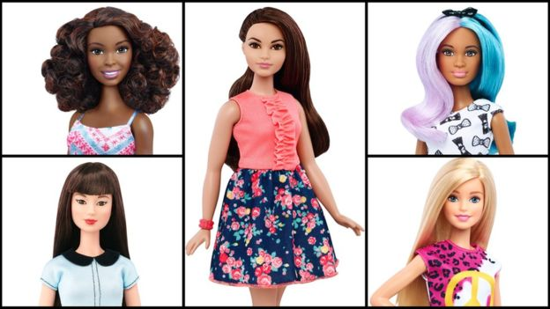
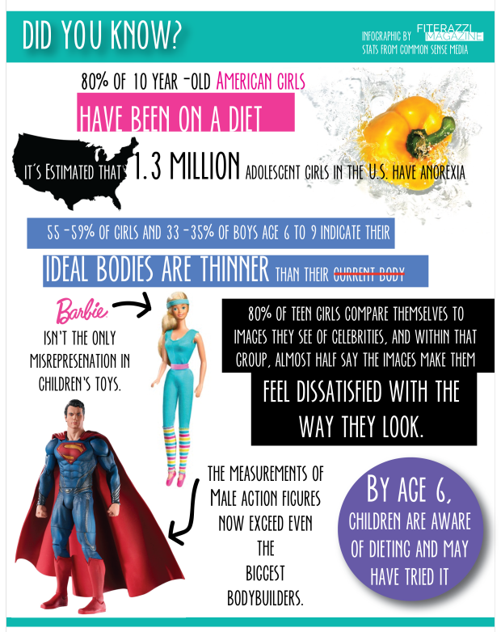
Source B)
Fiterazzi – American fitness magazine factsheet from 2015

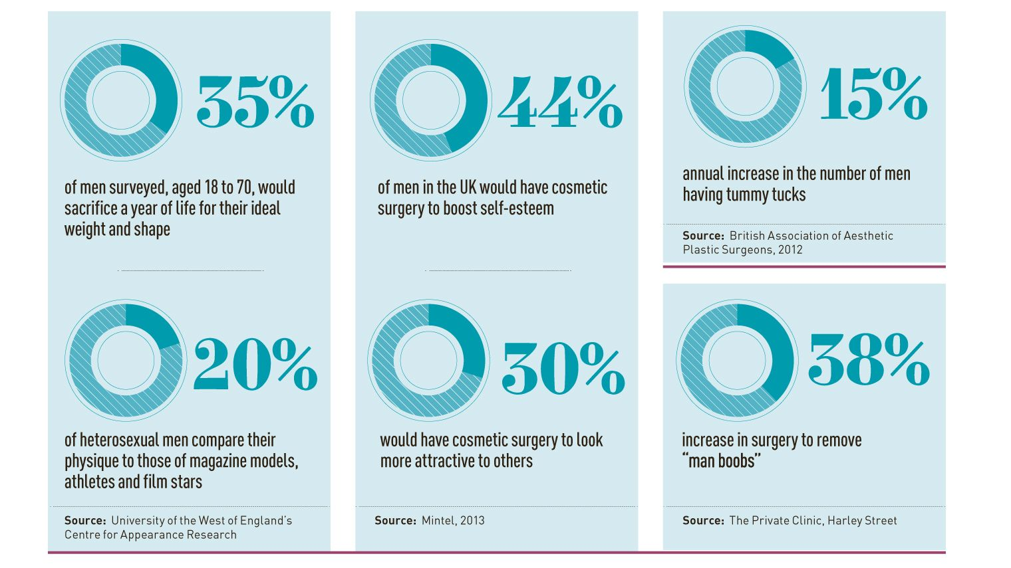
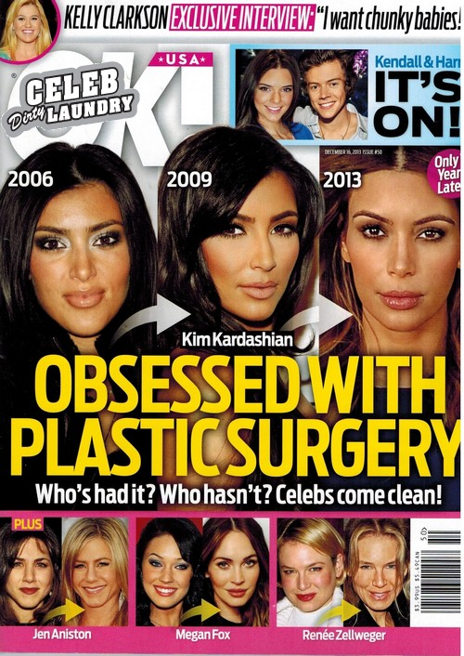
Source C
OK Magazine 2013 cover on Kim Kardashian

Source D)
Research on male cosmetic surgery from a top London clinic

Source E – Health sheet about how to gain positive body image put together by medical professionals
