KS3
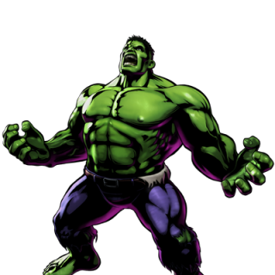
Seeing Red
Name:

THE ANGER RULES
It’s OK to feel angry BUT

- Don’t hurt others
- Don’t hurt yourself
- Don’t hurt property
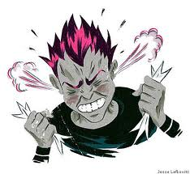
- Do talk about it

Task 1:
- On the body below, label all of the things that happen to your body when you get angry.
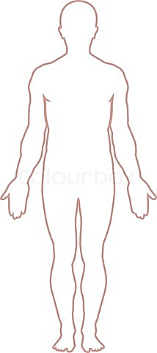
- Then in a different colour, list all of the things that could happen to the body when someone gets angry.

Sweaty palms
Task 2:
On the head below, write in all of the thoughts that go through your head when you get angry.
EG: “I want to run away” or “I want to break something”.
Task 3:
Draw your face when you are angry.

Task 4:
How many synonyms can you think of for the word ‘angry’?
Angry
Task 5:
You are a teacher in a secondary school.
Your name is Mr/Miss ………………… and you’re having a hard time trying to manage the behaviour of a certain boy who is being very disruptive in your lesson. The student is throwing things around to try and get people’s attention, he’s scribbling on his work, singing songs and is not letting the other people in his class do their work which is starting to get the other students pretty annoyed.
Your job is to try and calm the disruptive student down before his peers start to kick off at him.
What would you do?

And if that didn’t work?

Task 6:
Do you know what your triggers are?

A trigger is something that makes you go from calm to mad very quickly.

List 3 of your triggers
EG: Someone saying something nasty about my family

1.

2.
3.

Task 7:

Do you know what makes you feel calmer when your angry?
List 3 things that make you feel calmer
EG. Leaving the room to spend time alone

1.

2.

3.

Task 8:
From looking at these images, match the feelings that the person is feeling with the words in the middle

Sadness

Confusion

Anger

Fearful

Disgust

Happiness

Task 9:
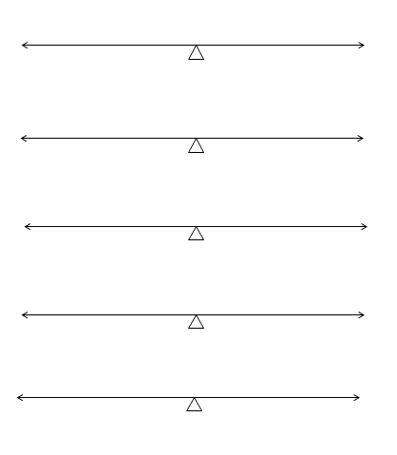
How I feel when I am at Home.
On the scales below, mark with an X where you think you belong.
Messy
Neat

Angry
Calm

Always think the worst
Always think the best

Sad
Happy
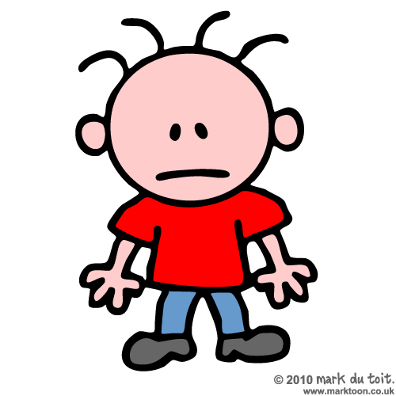

Friendly
Grumpy

Task 10:
How I feel when I am at School.
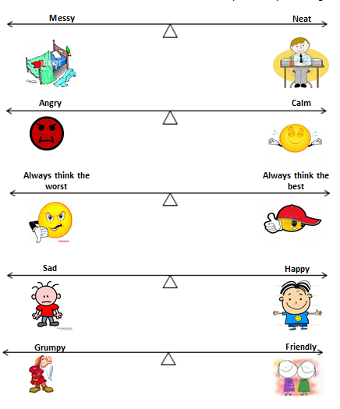
On the scales below, mark with an X where you think you belong.

Task 11:

Think of a time that you said or did something you regretted.
In the space below describe the…
T

Trigger Event (what happened):
____________________________________________
R

Reference (how you incorrectly evaluated the situation):
____________________________________________
U

Unhealthy Response (what you did that you now regret):
T

____________________________________________
Truth (what was really going on):
____________________________________________
H

Healthy Response (what you can do better the next time):
__________________________________________________
Some useful websites for dealing with anger

- www.kimscouncelingcorner.com

- www.teenshealth.org

- www.kidshelp.com.au/teens

- www.youngminds.org.uk

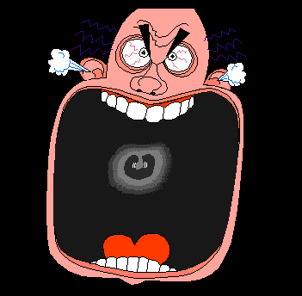

Task 12:
Anger can be caused by Stress.
Stress is when you feel things in your life are too hard. It can make you feel very angry, very sad and very confused.

Below are examples of common causes of stress. See how many you can think of to add to the diagram.

Struggling with school work
Common Causes of Stress
Arguments at home

Task 13:
There are 3 ways people show stress:
- Foot on the gas - Becoming angry or annoyed

- Foot on the brake - You become quiet and seem bored or tired

- Foot on both – You “freeze” under pressure and can’t do anything

Can you remember a time when you reacted each of these ways? Below, try to list a time when you felt like this.

Foot on the gas __________________________________________________
Foot on the brake
__________________________________________________
Foot on both
__________________________________________________
Task 14:

There are ways that work well for dealing with stress.

Below are examples of common ways to reduce stress. See how many you can think of to add to the diagram.

Dealing with Stress
Talking about your worries with friends, family or teachers
Avoiding arguments

Listening to music or drawing

Task 15:
Keeping thoughts positive is one of the best ways to stay feeling happy.
Don’t think - ‘Things always go wrong for me!’
Try - ‘Things aren’t going well at the minute, but if I keep trying they will improve’.
It seems silly but it works!
Try and think of 3 things that have happened to you this week that have made you feel happy
- ____________________________________________________

- ____________________________________________________

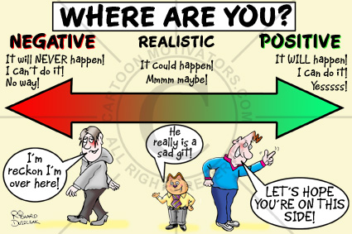
- ____________________________________________________

Task 16:
Which event do you think would cause each feeling?

You have been told off by your teacher for something that you didn’t do | 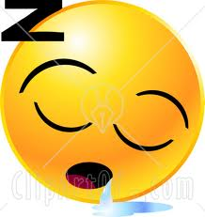
You’ve been asked to read your work out loud, but you hate public speaking
You woke up this morning and your dog had passed away
You have just been given tickets to see your favourite band
You’re stuck at home and aren’t allowed your TV, phone or to see friends
You said something really mean to a friend yesterday and now they’re upset
Task 17:
Draw yourself a shield that can protect you. You can draw on it things that keep you calm or make you happy and feel safe. It can be old fashioned, sci-fi or anything else you can think of. You can add words to it or colour it in.

Task 18:
Are you a volcano? Write words or even pictures in the lava to show what damage can be caused when you get angry.
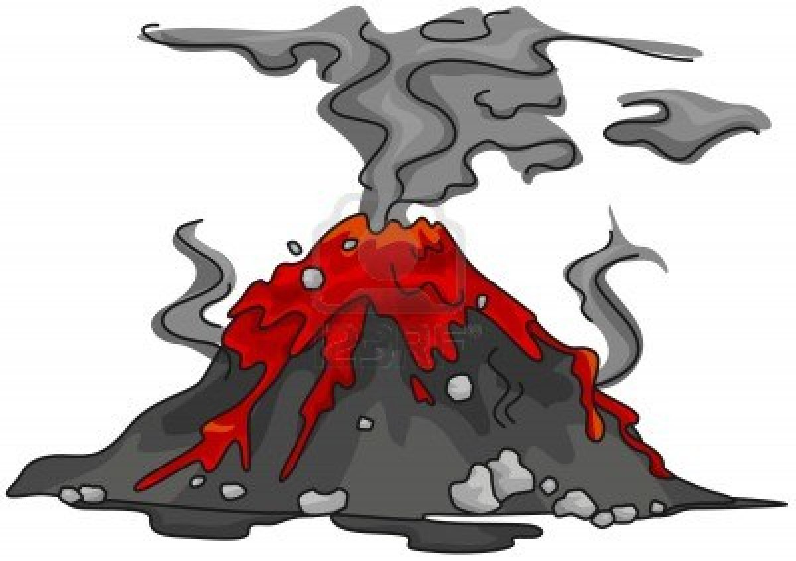

Task 19:
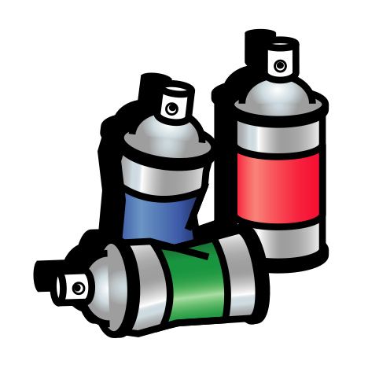
Here is a brick wall. You have been told that you are allowed to paint on it. Use different colours to graffiti on the wall, words to describe how you’re feeling and pictures to show why you feel this way.

Task 20:
Cross out the emotions which are negative feelings, leaving the positive feelings on show. Add any others you can think of.
Fear
Worry
Bored
Excitement
Jealousy
Love
Surprise
Anger
Shame
Guilt
Sadness

