Administration Process
and
Application Form

International Registrations

Buckswood School: a Highly Trusted Sponsor
UK Visas and Immigration

Application Checklist

1. Completed Application Form
2. Recent passport-sized photograph of your child
3. Deposit and Registration fee: payable by card or cash
4. Recent school reports
5. Passport copy
6. English Test

□ Cash

□ Card

Tick
□
□□□□□

We will then send you:
1. Signed letter of acceptance
2. Student Starter Pack
(including: Medical Form; Subject Choices for GCSE, A-Level or IB; Permission Forms; Uniform List; etc.)
IMPORTANT: Please note that if we do not receive a completed Medical Form for your child, we may not be able to administer medical treatment, should it be required.

Please ensure you have supplied us with a copy of your child's passport.

As a UKVI Highly Trusted Sponsor; Buckswood School will supply a Confirmation of
Acceptance for Studies (CAS) number as part of the Points-Based System requirement for visa nationals. It is the parents'/guardian's responsibility to ensure that they have all documentation and financial arrangements in place prior to making an application to the relevant consulate office.
Buckswood School has a responsibility to reject and report any application it considers
to be inappropriate or potentially in contravention of UKVI regulations.

Contact:
EU: admissions@buckswood.co.uk
Non EU: registrar@buckswood.co.uk

For full terms and conditions visit
www.buckswood.co.uk/terms-conditions

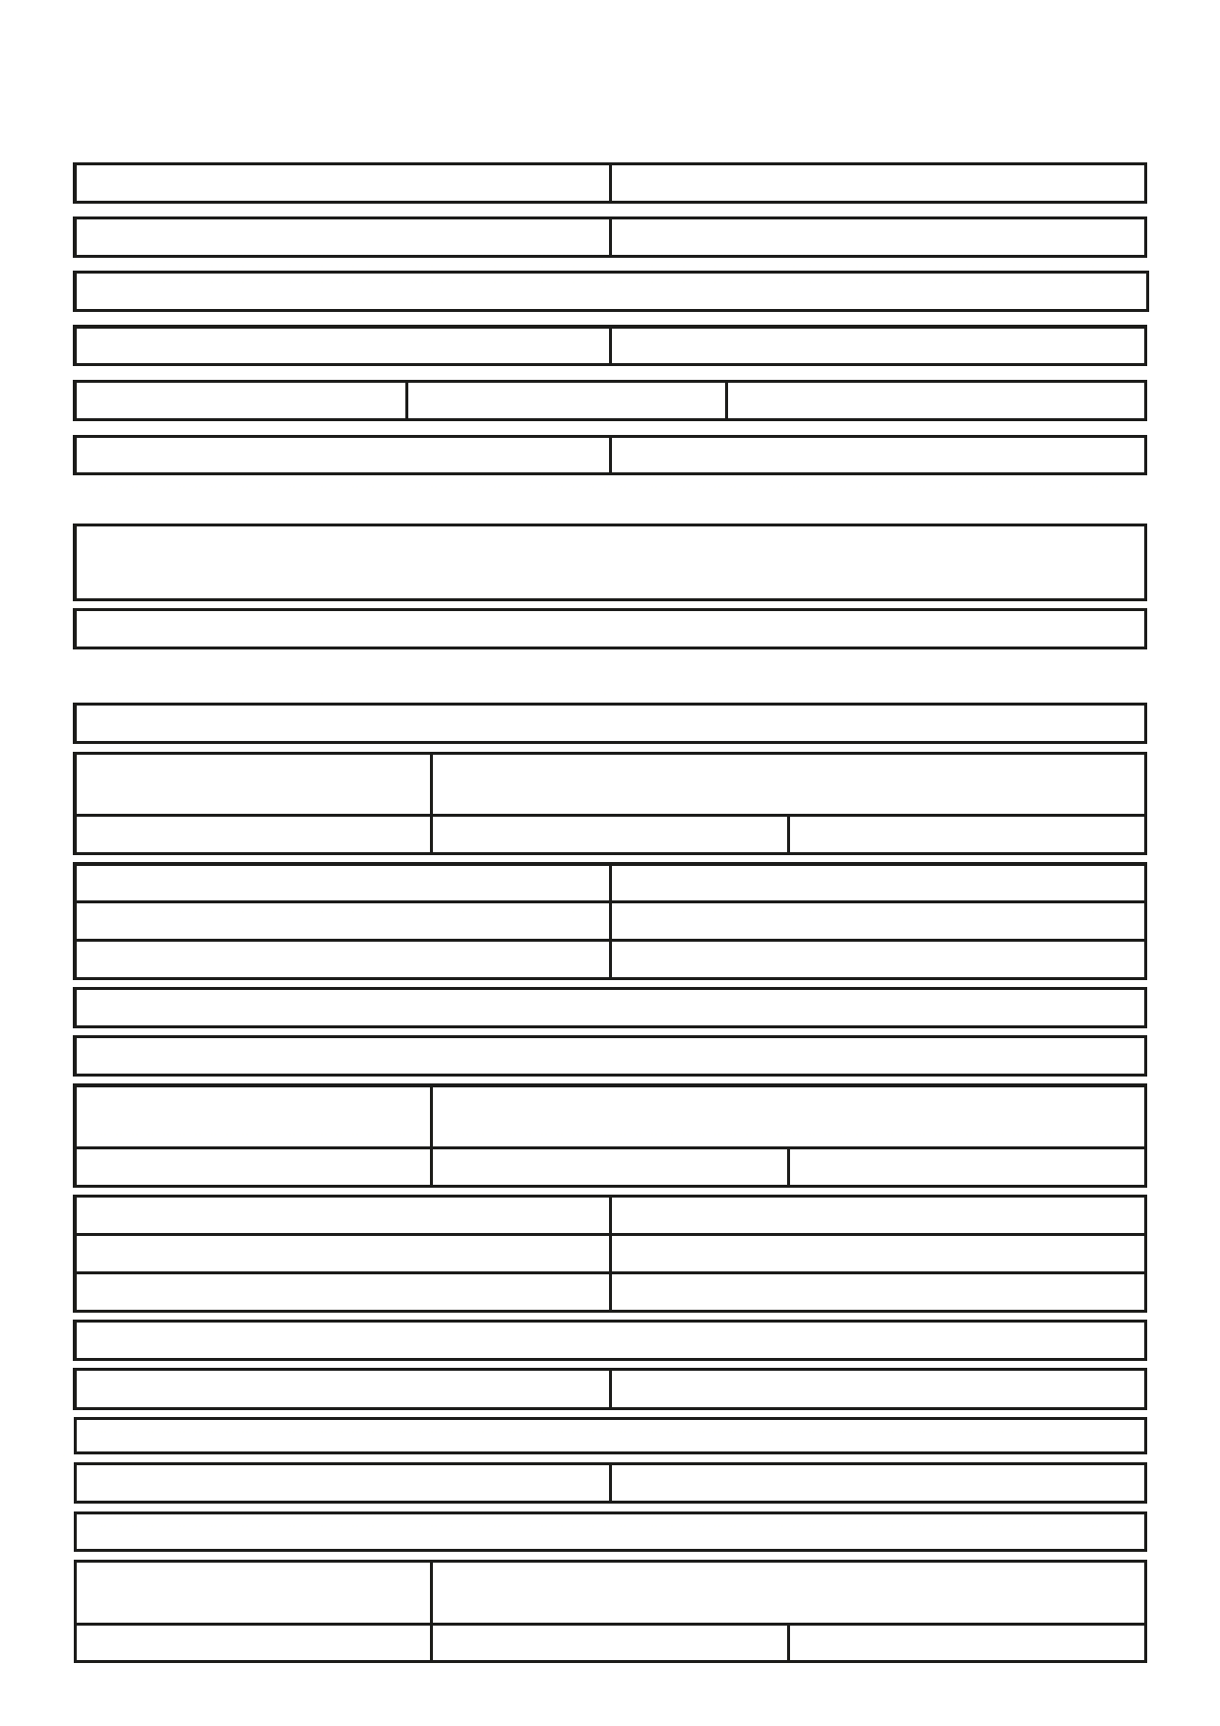
Application for admission to Buckswood School as a:
□ Full Boarder □ Football Academy Boarder
Nationality First Language

Place of Birth: City Country

Student's Surname / Family Name

First Name Middle Name

□ Male □ Female Date of Birth D D / M M / y y y y

Expected Start Date MM / y y y y Expected Length of Stay MM / y y y y

Academic Course: □ Junior □ GCSE □ IGCSE □ A Level □ IB □ UFC □ Short Courses

List any ESL qualifications held:

Does the child require additional help with his or her studies?

FAMIly INFORMATION
Father's Name

Home Address: House Number
City

Phone Country Code:
Mobile Country Code:
Fax Country Code:

Email PLEASE PRINT CLEARLy

Mother's Name

Home Address (if different from above)
House Number
City

Phone Country Code:
Mobile Country Code:
Fax Country Code:

Email PLEASE PRINT CLEARLy

Street

Postal Code

Street

Postal Code

Number:
Number: Number:

Number:
Number: Number:

Country

Country

Does the child live with both parents? □yes □ No If not, with whom does he/she live?
If not, with whom does he/she live?

Are the parents separated or divorced? □yes □ No If yes, who has legal custody?

To whom should all correspondence be sent?

Address (if different)
House Number
City

Street

Postal Code

Country

Continued overleaf

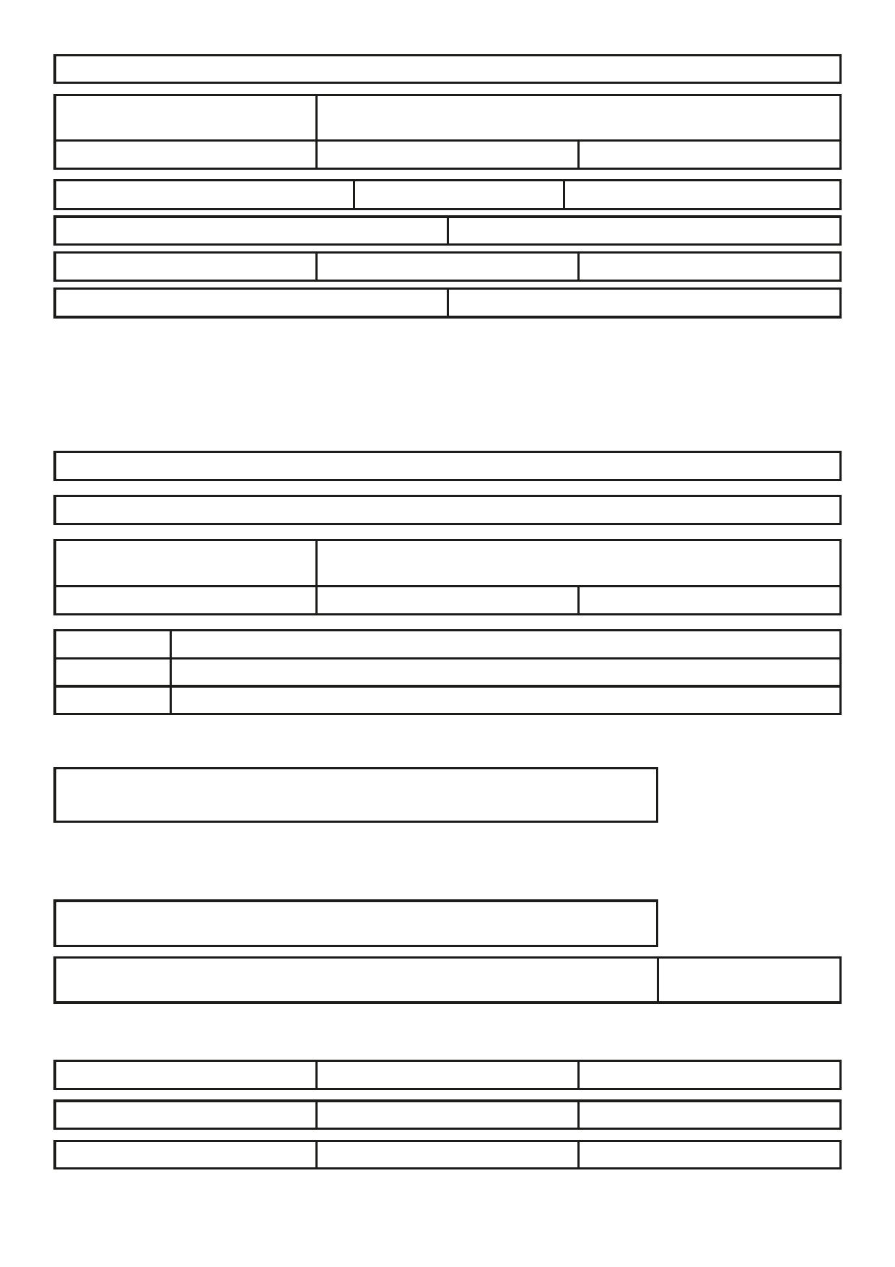
To whom should all the bills be sent?

Address (if different)
House Number
City

Street

Postal Code

Country

Was the child adopted? □ yes □ No If yes at what age? Does he/she know? □ yes □ No

Passport Number Expiry Date D D / M M / y y y y

Visa held? □ yes □ No If yes what type? Expiry Date D D / M M / y y y y

Previously refused a Visa? □yes □ No If yes why?
Parents resident overseas must nominate a Guardian, resident in the UK, who is fully responsible for the child in the
absence of parents. Unless informed otherwise, the school will act as legal guardian and a fee of £150 per term will be charged. Please see Terms and Conditions on the Buckswood website.

Do you wish to use the school's guardianship assistance scheme? □yes □ No
If no complete below:

I nominate as my child's guardian in the UK Mr / Mrs / Ms:

Relationship to the applicant

Address (if different)
House Number
City

Street

Postal Code

Country

Home: Number:
Mobile Number: Business: Number:

I hereby agree to act as guardian, and accept full responsibility for the above pupil whilst at Buckswood School.

Guardian's Signature

All APPlICANTS TO COMPlETE
(I have read and agree to the Terms and Conditions on the Buckswood website)

Father's Signature

Mother's Signature

EMERGENCy CONTACTS

1. Name

2. Name

3. Name

Mobile Country Code

Mobile Country Code

Mobile Country Code

For full terms and conditions visit

Number

Number

Number

Date D D / M M / y y y y

www.buckswood.co.uk/terms-conditions

